Creating a Profile

Via computer
Step 1:Go to: https://jefferson-lehigh.cloud-cme.com

Step 2: Click Sign In, and sign in using your email address and password.

Step 3: Click the My CME or My CE button.

Step 4: Click the Profile button.

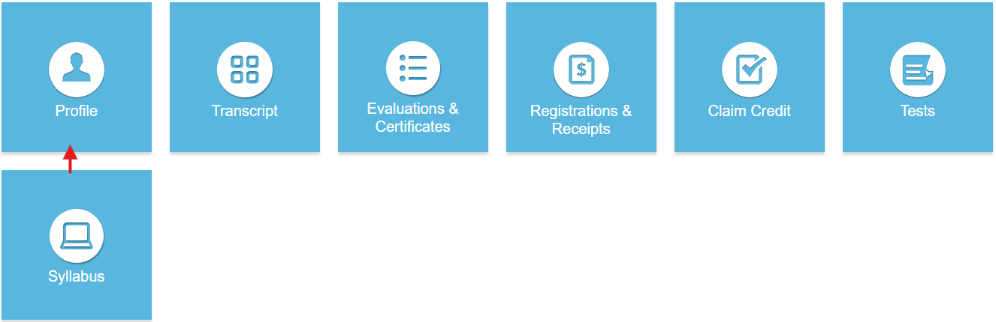

Step 5: Complete all fields.

NOTE: Fields marked with an asterisk are required. You must select your Degree and Profession to receive credit upon activity completion.

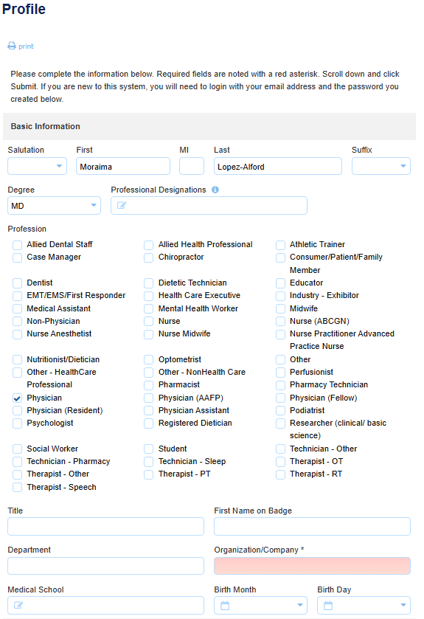
Step 6: When all information has been entered, click the Submit button at the bottom of the screen. Your CloudCME® account has been created.

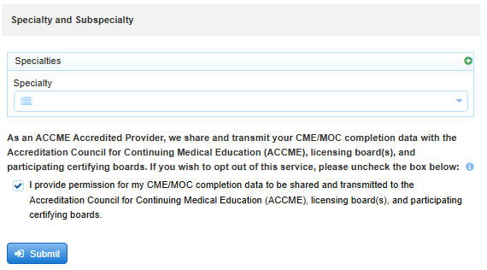

Via CloudCME App
Step 1: Open the CloudCME App.
Step 2: Login using your email address and password.
Step 3: Select Profile on the menu, if available.
Step 4: Complete all the fields and click Submit.

